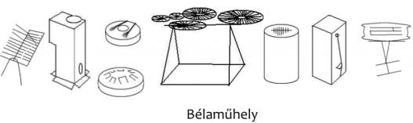
Conductor game
Game, Improvisation, Interaction

Our production called Conductor game stands from 3 parts. The first part includes individual and common playing on the instruments by the musicians, so the audience, and the future conductors can get an idea of the sounds.
In the second part, everyone can try the instruments, ask questions about how they were made, from what material, about how to play on them, etc. This is also a part for signing up for the contest.
The third part is the conductors’ part. The attendees can get the musicians to play their instruments with no previous instructions, only with movements, posture, mimics and gestures. This way we can experience short, improvisative compositions borning. It is a very enjoyable game, for the audience and for the conductor as well.

